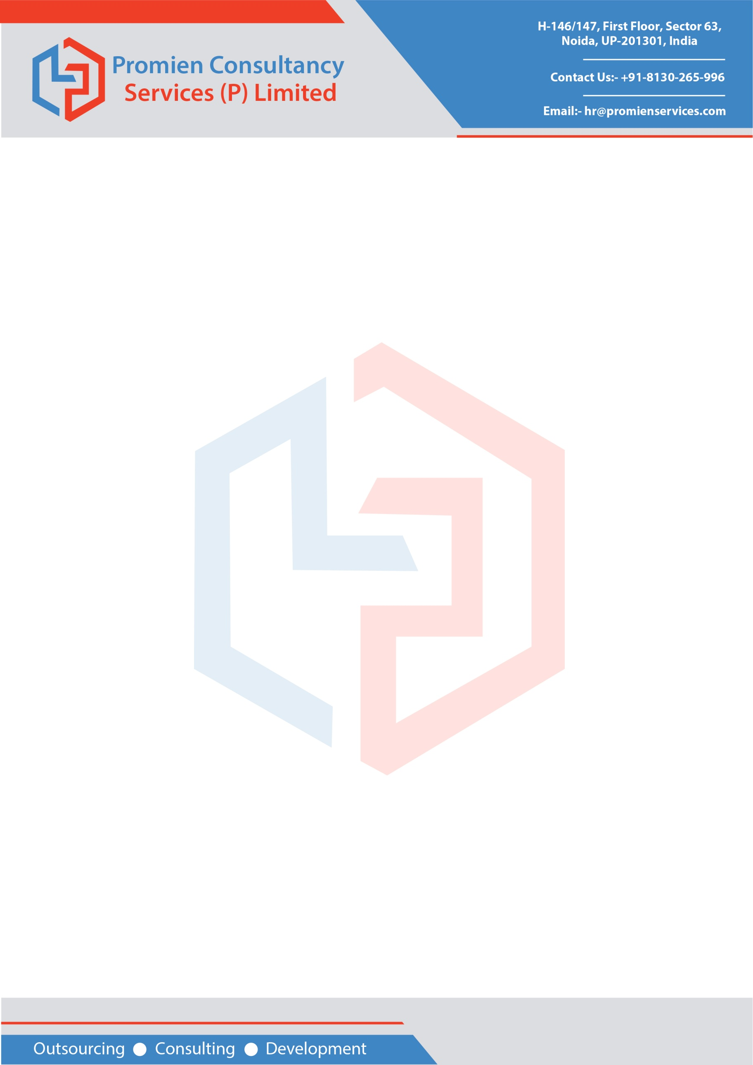

**TO WHOMSOEVER IT MAY CONCERN**

This is to certify that Mr. Prateek Saini Son of Mr. Hukam Singh Saini was working here at Promien Consultancy Services (P) Limited as Mechanical Design Engineer from 16th November 2015 to 04th January 2018 as a full-time employee.

Mr. Prateek Saini has excellent communication skills. He is well skilled, organized, sincere and diligent in discharging his duties. He is a conscientious worker and has an excellent work ethic. He would prove to be an asset for any Organisation he works in the future and we sincerely wish him all the best for his future endeavors.

Please refer to the below responsibilities and designation held by him:

**Designation** - Mechanical Design Engineer

**Period**          - 16th November 2015 to 04th January 2018

**Salary**          - INR 2,24,400.00

**Type of job** -  Full-time permanent  worker (40 hours  in a Week)

**Responsibilities:**

* Communicate and discuss design requirements and standards with clients.
* Create detailed technical reports with summarized findings.
* Design components according to technical design standards and specifications.
* Use of CAD and Simulation software to design and analyze components.
* Perform advanced dynamic analyzation using Finite Element Analysis and other simulation techniques.
* Involved in creating and planning a new production process.
* Improving the design, performance, and efficiency of existing products.
* Effective planning of the design process to meet standards budget and deadlines.

         .

   We assure you that the above details pertaining to Mr. Prateek Saini are based on the records maintained by our office. We wish him all the best for his future.

Regards

Signature

Designation

Phone No

Email address

Seal of Company